Assistent

Programmierdokumentation



Neutorstraße 13  
5020 Salzburg

AUSTRIA

Tel: +43 (662) 276198-11

Fax: +43 (662) 276198-98

Mail: [office@breanos.com](mailto:office@breanos.com)

|  |  |
| --- | --- |
| Version | 0.2 |
| Date | 22.06.2018 |

Table of contents

1 Table of revision 4

2 Microservice application 5

2.1 All.Interfaces.Standard 5

2.2 Assistant 5

2.3 AssistentInternalInterfaces 5

2.4 AssistantUtilities 5

2.5 AssistentViewerInterfaces 5

2.6 BIKSClassLibrary 5

2.7 Blackboard Actor 5

2.8 BlackboardClassLibrary 5

2.9 CoreService 6

2.10 ExternalCommunicationService 6

3. Deployment 6

# Table of revision

|  |  |  |  |
| --- | --- | --- | --- |
| Date | Version | Editor | Description |
| 2018-06-22 | 0.1 | EBE | Initial version of programmer dokumentation. |
| 2018-06-25 | 0.2 | EBE | Extended document. |

# Microservice application

All microservices are using a centralized Breanos logger instance. This instance is configured with help of the NLOG.config file. There are 2 logging SQL servers in the Breanos environment.

|  |  |  |
| --- | --- | --- |
| **Servertyp** | **IP-Address** | **Instance name** |
| SQL-Server | 192.168.30.3 | SQL2016 |
| SQL-Server | 192.168.50.50 | SQL2017 |

## All.Interfaces.Standard

Project which contains all interfaces for the Blackboard communication. It is a .NET Standard project and can be used in all other services. (.NET Framework, .NET Core).

## Assistant

Deployment project for SFA application. Can be deployed locally and remote on the cluster.

Be aware that **AccessControl** and **KPU project** is also deployed on the server.

## AssistentInternalInterfaces

Collection of all Microservice interfaces. To be used everywhere in the application. It is a .NET Standard project and can be used in .NET Framework projects as well as in .NET Core projects.

## AssistantUtilities

Here are all Helper classes. Breanos Logger is used in the whole application to log into the database and into text files.

## AssistentViewerInterfaces

Here in you can find the interfaces to the AssistantViewer SignalR interface which is connected to the app.

## BIKSClassLibrary

BIKSClassLibrary contains demo DTO for internal use. Used to transport data with the Service Bus.

## Blackboard Actor

Blackboard actor represents the container service class which holds the Blackboard implementation. To startup the blackboard call InitBlackboard and StartProcessing. The blackboard is listening to the ServiceBus. It has a separate knowledge source with an asynchronous handler. BreanosServiceBusMessages contains a ServiceBusConnector instance which is imported by the internal Breanos nuget server. This is a .NET Framework service.

## BlackboardClassLibrary

Here is the Blackboard implementation which is used in the Blackboard. All Knowledge sources, Service Bus implementation. Please adapt Service Bus topic and connection string setup in the BreanosServiceBusMessages class.

## CoreService

Core Service is a stateless Service which is instantiating Presenter, ExternalCommunication and Blackboard Service. Here is also Testcode to call Wexflow workflow instance.

## 2.10 ExternalCommunicationService

ExternalCommunicationService is the Service which is communicating with SignalR clients.

The newest .Net Core 2.1 SignalR implementation is used. Our standard communication port is: 4042. The PresenterViewer is directly communicating over SignalR with the Assistant Application.

## 3. Deployment

The Assistant can be deployed directly into a Service Fabric cluster via Visual Studio.

The current development source code can be found on our git server. Follow the following URL: <http://bre-tfs02:8080/tfs/daipan/_git/Assistant>.

The solution can be deployed on a local Service Fabric cluster or on a remote cluster.

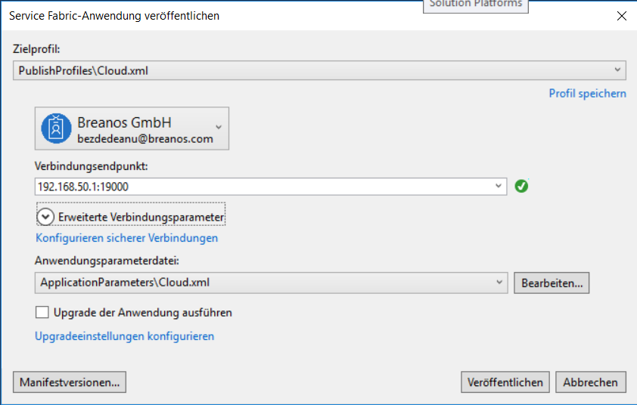

Here is a list of all services which are deployed with the solution:

|  |  |
| --- | --- |
| **Service name** | **Instances** |
| Blackboard | 1 |
| CoreService | 1 |
| ExternalCommunicationService | 1 |
| Presenter | 1 |
| SecurityService | 3 |

Healthy deployed Assistant Application in Service Fabric Explorer:

